Component Breakdown (Recruiter flow)

1. **Global**

* **Header**

Type: Presentational (Global)

Data: state.user

Action: logout (user reducer)



* **Footer**

Type: Presentational (Global)

Data:

Action:



* **Login**

Type: Presentational

Data: state.employee

Action: login (user reducer)

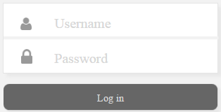

1. **Dashboard**

* **RecruiterDashboard**

Type: Container

Data: state{candidateProfile, emplyee, currentTab, user}

Action: toggleFilter, addRound

* **DashboardStats**

Type: Presentational (Global)

Data: state { candidateProfile, user}

Action:



* **PieChart**

Type: Presentational (Global)

Data: custom data

Action:



Dashboard Details (Same for Panelist)

Type: Container

Data:

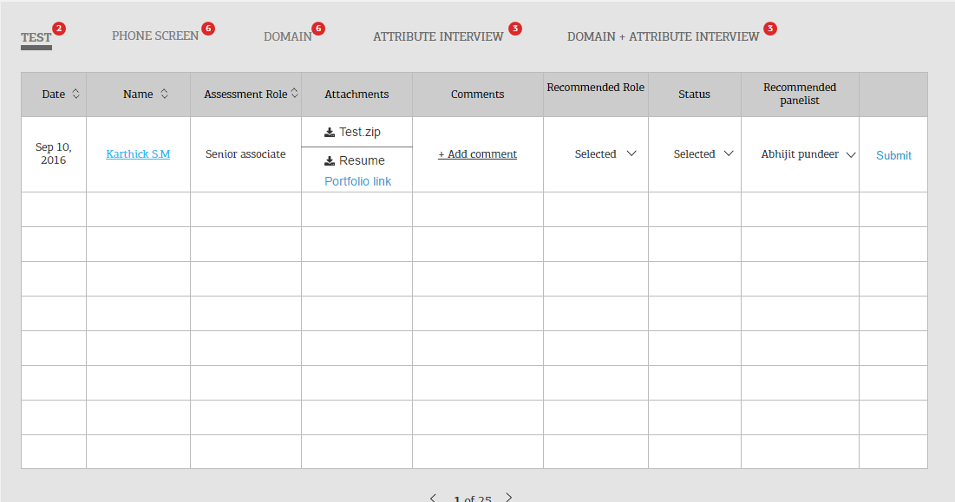

Navigation Tab List

Type: Container

Data:



Navigation Tab Item

Type: Presentational

Data:



Grid

Type: Container

Data:

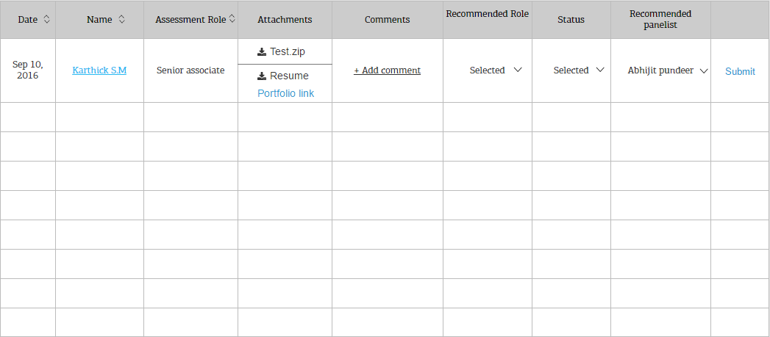

Grid Item

Type: Presentational

Data:



Grid Header

Type: Presentational

Data:

C:\Users\ksin68\Desktop\gridheader.PNG

Dropdown (Global)

Type: Presentational

Data:



Pagination (Global)

Type: Presentational

Data:



* **NextStepOverlay**

Type: Presentational

Data: state.employee

Action: AddRound

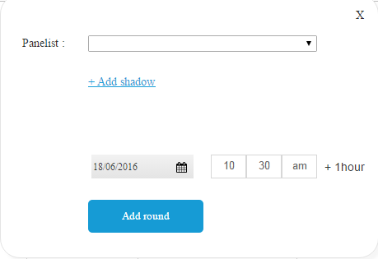

* **AddShadow**

Type: Presentational (Global)

Data: state.employee

Action:

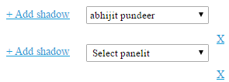

* **DatePicker**

Type: Presentational (Global)

Data:

Action:



* **Pagination**

Type: Presentational (Global)

Data: state {currentTab, user, candidateProfile}

Action:



1. **Add Candidate Page**

* **AddCandidate**

Type: Container

Data: state.employee

Action: addCandidate

* **PersonalDetails**

Type: Presentational

Data: state.employee

Action:

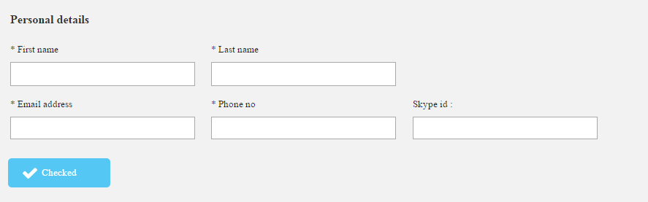

* **ApplicationDetails**

Type: Presentational

Data: state.employee

Action: addCandidate

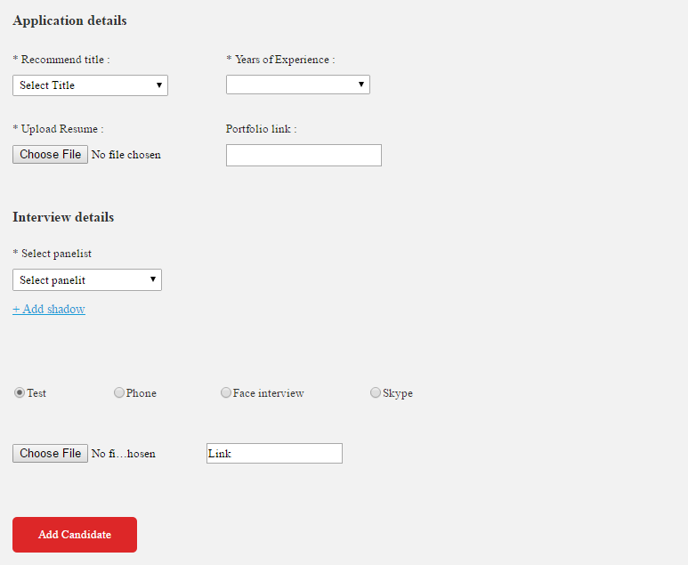

1. **Search Page**

* **Search**

Type: Container

Action:

* **CommentsPopup**

Type: Presentational (Global)

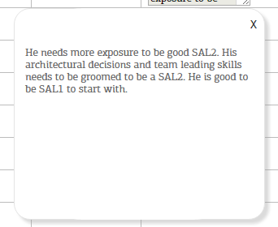

1. **Candidate Profile Page**

* **CandidateProfile**

Type: Container

Data:state{candidateProfile,candAndInterviewDetails}

Action:

* **CandidateInformation**

Type: Presentational

Data:state{candidateProfile} (selected candidate through query params)

Action:

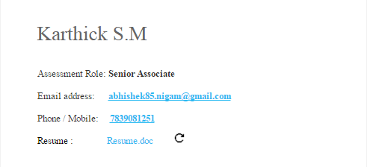

Rating List (Global)

Type: Container

Data:

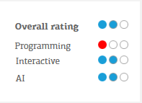

Rating Item (Global)

Type: Presentational

Data:

**

* **InterviewRounds(Grid-global)**

Type: Container